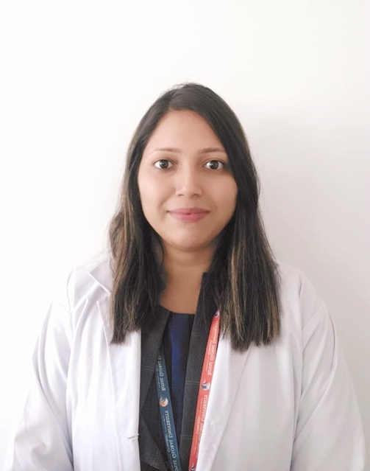

Dr. Lopa Das (PT), Associate Professor/ School Coordinator, Royal School of Medical and Allied Sciences, The Assam Royal Global University

Qualification:
Masters of Orthopaedic Manual Therapy ,KLE University (2008 -2010)
Bachelors of physiotherapy (2003 -2007)from Rajiv Gandhi University of Health Sciences(RGUHS), Karnataka

Work Experience :Total 14years(12 years Academic )
- Sports Physiotherapist , Assam Cricket Association 2010-1011.
- College of Physiotherapy and Medical Sciences, PEWS Group of Institutions, Guwahati.(2011-2019)
- NEPNI Group Of Institutions 2020-2021.
- The Assam Royal Global university (April 2021 – till date )

PUBLICATIONS :
Research publications : 4

Training / Internship:
Hospital | Designation | Duration
PG Trainee in Dr Prabhakar Kore Hospital and Medical Research Centre, Belgaum , Karnataka | Masters of Physical Therapy (Training) | For the period of 2 years
Physiotherapy Intern Manipal Hospital, Bangalore | Masters of Physical Therapy (Training) | For the period of 3months, 2008
Physiotherapy Intern in Chinmaya Mission Hospital , Bangalore | Intern | For the period of 1 month 2008
Physiotherapy Intern WOCKHARDT Hospital | Intern | For a period of 1 month year 2008
Physiotherapy Intern St. Philomenas Hospital, Bangalore | Intern | For a period of 1 month year 2008

Professional Membership & Certification:
- Life Member of Indian Association of Physiotherapists Registration number (L-29765) .

Dissertation during MPT:
- Effectiveness of Mckenzie Technique and Neural Mobilization Technique in Chronic Lumbar Radiculopathy (2008 – 2010)

